Alexander Zhedelev
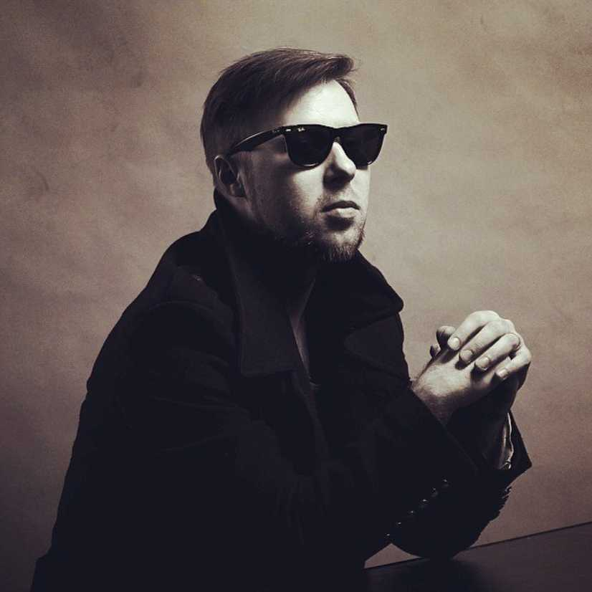
(Tallinn, Estonia)
Alexander Zhedelev is a composer, a guitar-player and a teacher. Since 2006 he has also been the Musical Director of Vene Teater (Estonia) .
In 2006 Alexander graduated from the Jazz Guitar Department of the Musical College after G. Ots (Mart Soo’s class). Since 2012 he has been taking a course of audio-visual composition at Estonian Academy of Music and Theatre.
Since 2006 he has been the leader of the fusion jazz ensemble TRIOPHONIX. He also works as the director and an author for the Audiokinetika group of musicians and artists creating audio-visual performances and installations.
In 2008 he started teaching Musical Education at the acting studio of the Vene Teater, Estonia.
Alexander Zhedelev has composed soundtracks for over 30 theatrical performances and original music for over 10 shows in Estonia, Poland and Russia. In 2014 his music for “Antigona” has been nominated for the annual Theatre Prize of Estonia. He has also created music for 10 films and animated cartoons.
Since 2012 he has been co-working with the actor Anton Shagin on the project “Stykhomuzy”.

Balázs HORVÁTH
(Budapest, Hungary)
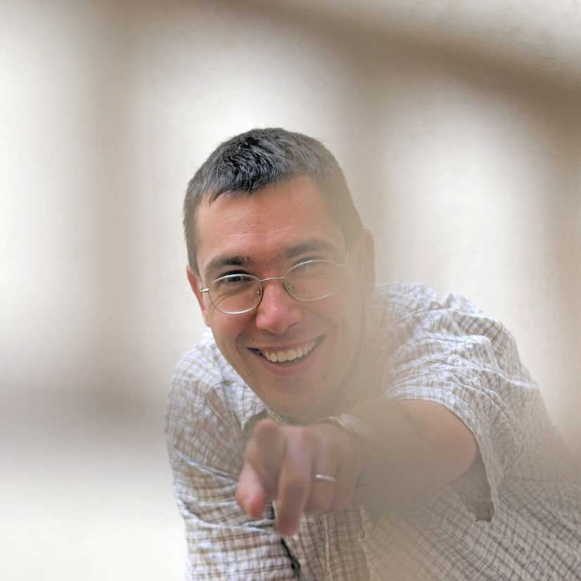
Balázs HORVÁTH was born in Budapest in 1976. He studied composition at the Ferenc Liszt Academy of Music with Zoltán Jeney, Attila Bozay, and János Vajda. While teaching there, he has finished his DLA in Composition in 2005.
His pieces are performed in Hungary and abroad as well, e.g. Budapest Spring Festival, Gaudeamus Music Week in Amsterdam, Bartók Festival in Szombathely, Huddersfield Contemporary Music Festival, Music of Today in London, Music in Current, Tokyo, the ISCM World Music Days (2003 Ljulljana, 2009 Göteborg, 2011 Zagreb), Musikprotokoll, Graz, cresc. Biennale für Musik, Frankfurt. He worked with perfomers and conductors such as Péter Eötvös, Rivka Golani, Gergely Vajda, Pierre-André Valade, Howard Williams, the Amadinda Percussion Group, the Ensemble Modern, the Göteborg Symfoniker, the Big Band of the Croatian Radio, the Symphony Orchestra of the Hungarian Radio, the RSO Wien, the Tokyo Sinfonietta, the Ensemble UMZE among others.
In 2007 Horváth won the 1st Prize with his composition POLY at the “In Memoriam György Ligeti” composition competition in Berlin (2007) and he was also among the prize winners at the New Hungarian Music Forum in 2009, 2011 and 2013 (1st and 2nd prizes).
Horváth regularly appears as conductor and performer at special occasions and performances of contemporary pieces. He founded THReNSeMBle with six young musicians with whom they perform contemporary music, especially from young composers. The last five years THReNSeMBle played World premieres of more than 30 pieces in Hungary and abroad.
As composer nowadays he is interested in the combination possibilities of popular and serious music and integrating theatrical elements into music.

Oleg Paiberdin
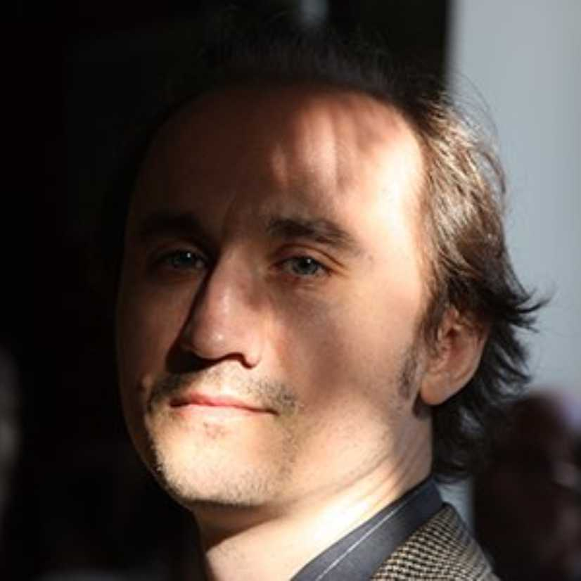
(Moscow, Russia)
Oleg Paiberdin was born on Deсember 13, 1971 in Altai, Russia. As a child he lived in Karatau, Kazakhstan, where he attended his father V. Paiberdin’s class at the Music School.
He graduated from the Urals State Conservatory after M.P.Mussorgsky in 1996 and completed a postgraduate course of composition there in 1999 (Prof. A.Nimensky’s class).
He has attended workshops given by Avet Terteryan (Yekaterinburg), Sergey Berinsky (Ivanovo), Paul-Heinz Dittrich, Sergey Slonimsky, Ernst Helmuth Flammer, Karl Stamer (III International Seminar of Contemporary Music “Sound Ways”, St. Petersburg), Georges Apergis, Pierluigi Billone, Rebecca Saunders, Chaya Czernowin (The 45th and the 47th International Summer Courses for New Music in Darmstadt, 2010, 2014), the Luxembourg Sinfonietta ensamble (Workshop for Composers “Europe Meets China”, Luxembourg). Paiberdin has been awarded grants of the Academy Schloss Solitude, Kuenstlerhaus Closter Zismar and Kuenstlerhaus Lukas (Germany), and the Visby International Centre for Composers (Sweden). He was among the laureates of the III Prokofiev International Composers' Competition (St. Petersburg, 1999) and the II International Contemporary Music Competition “Composer of XXI Century” (Kaluga, 2014).
He has been a member of the Union of Composers of the Russian Federation since 1997. Since 2006 he has been working at Moscow State Philharmonic.
Between 1998 and 2005 Oleg Paiberdin acted as one of founders and managers of the Autograph New Music Workshop in Yekaterinburg. He is the founder, artistic director and conductor of the Gallery of Actual Music Ensemble (GAM-Ensamble). He also collaborates with the publishing houses “Composer” (Moscow) and “New Consonant Music” (Belgium).
Oleg Paiberdin took part in a number of festivals in Russia, Ukraine, Belgium, Estonia, France, Germany, Latvia, Lithuania, Luxembourg, Macedonia, the Netherlands, Scotland and Japan.
He was the master-mind and the artistic director of The Other Space Actual Music Festival at Moscow State Philharmonic (2009, 2010, 2012). He also contributed in arranging and producing numerous events in Yekaterinburg, Moscow, Novosibirsk, Syktyvkar, Nizhny Novgorod, Surgut, and Perm.
His music has been performed by the Urals Philharmonic Orchestra, Rivne Philharmonic Chamber Orchestra, Yekaterinburg New Music Ensemble, Image String Quartet, Boehm Flute Quartet, Ferdinand Cello Quartet, the “Other Orchestra” (Yekaterinburg), Moscow Saxophone Quartet, Syrinx Flute Quartet, Studio for New Music Moscow, Moscow Contemporary Music Ensemble, Gallery of Actual Music Ensemble, XX Century Ensemble, Romantic String Quartet, Twelve Cellists directed by Olga Galochkina (Moscow), eNsemble (St Petersburg), Laboratory for New Music Ensemble (Novosibirsk), Archi, Ricochet (Ukraine), Neue Vocalsolisten Stuttgart, SurPlus (Germany), Ensemble ’88 (Netherlands), Goeyvaerts String Trio, Alcatrasax-quartet (Belgium), Quattro Differente (Latvia), Scottish Clarinet Quartet, Luxembourg Sinfonietta, Sax Est (Estonia), Viola Ensemble of Tokyo Music College (Japan) – and various soloists, such as Sergei Astashonok, Michail Bereznitsky, Danila Galochkin, Alexander Zagorinsky, Andrei Kravchenko, Ilia Lundin, Oleg Tantsov, Edyta Fil, Mona Khaba, Yekaterina Antokolskaya, and others.

Jakub Rataj
(Prague, Czech Republic)
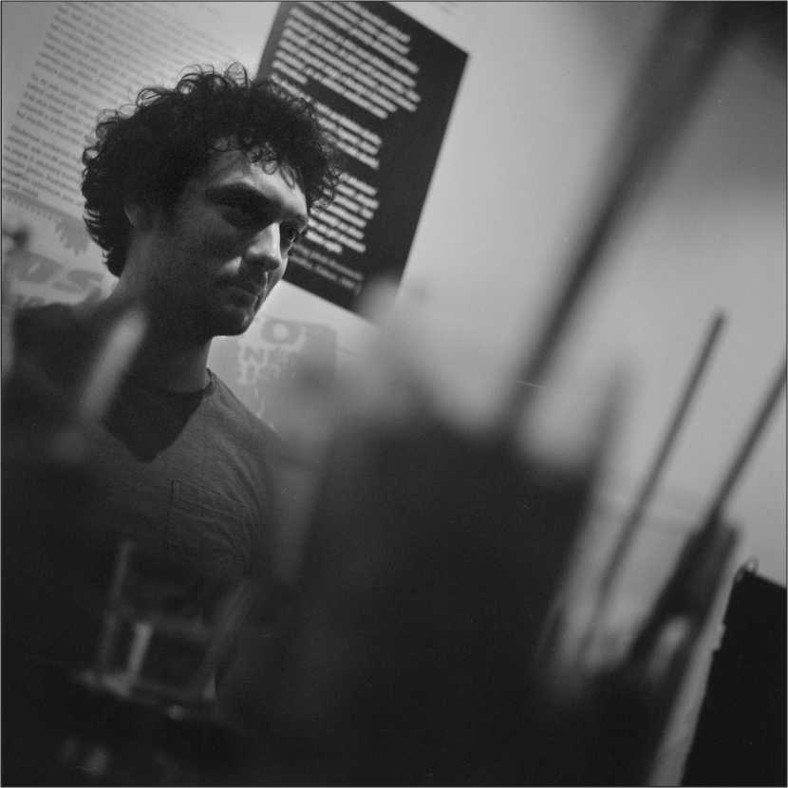
Jakub Rataj (*1984) is a Czech composer of orchestral, chamber and electro-acoustic music. His work includes interactive sound installations and performances inspired by the human body, movement, breath, pulse and gesture. Jakub is a member of O.E.M. ARTS – a Czech art group comprising of and connecting contemporary artists from the fields of sound performance, animation, and light design – where he’s playing electric guitar and processing sound by using sensors.
His compositions have been performed on many concerts and festivals worldwide, he was commissioned by ensembles such as Orchestr Berg, Prague Modern, MoEns and has worked with various choreographers, film directors and animators. In 2013-2014 he studied composition and new technology with Luis Naon at the Conservatoire National Supérieur de Musique et de Danse de Paris. In Czech Republic, he is studying composition with Hanuš Bartoň at the Academy of Performing Arts in Prague. He took classes, among others, with Isabel Mundry, Frédéric Durieux, Yan Maresz, Yan Geslin, Oriol Saladrigues and Tom Mays. In 2014 he was awarded the main price Nuberg for the piece Proraketon (for Raketon and chamber orchestra) commissioned by the Orchestr Berg.

Sergey Zyat’kov
(Surgut, Russia)
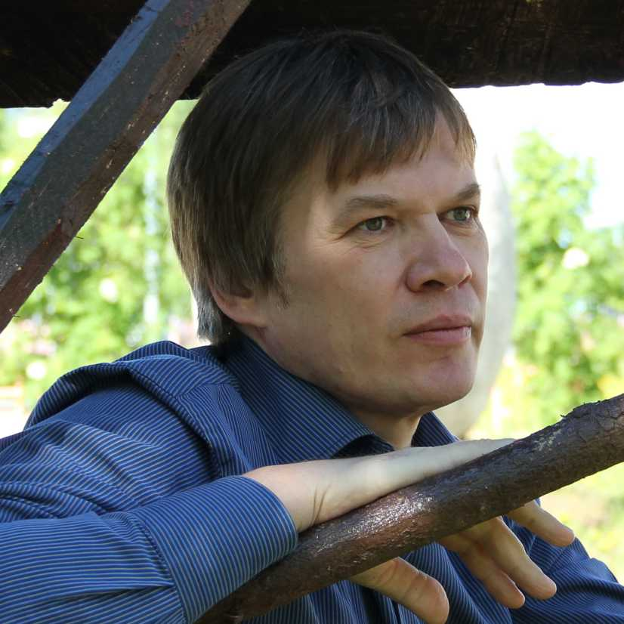
Sergey Zyat’kov was born in 1969 in Kurgan. He graduated from the Urals State Conservatory after M. Mussorgsky (I.V. Zabegin’s class). He has been a member of the Union of Composers of the Russian Federation since 2004.
Sergey has participated in the seminars for young composers held by V. Yekimovsky (Ruza, 2004, 2006) and the International Summer Courses for New Music (Darmstadt, 2010, 2012).
Sergey Zyat’kov has created over 50 chamber, symphonic, experimental, theatrical and children’s works. His music has been performed by philharmonic symphony orchestras of Novosibirsk, Omsk, Tambov, Surgut; by Moscow ensembles – such as the Studio for New Music, “Romantic-Quartet”, the Moscow Ensemble of Contemporary Music, “GAM-Ensemble”, “XX century”, “Cart-blanche”, and by soloists, including A. Zagorinsky (cello), F. Amirov, M. Khaba (piano).
Zyat’kov is a supervisor of audio-visual projects at the contemporary art gallery “Sterkh”: in 2011 and 2013 his projects were awarded the “Sobytie” (“Event”) Prize of Khanty–Mansi Autonomous Okrug- Yugra Department of Culture.
“Listening to Sergey Zyat’kov’s music one might several times recall the metaphor of the musical meadow. The composer succeeds in creating factures that are continuous and static but filled with inner life. He is spell-bound by the glimmering of the pitch, rhythm, tembre and dynamics”. (Olga Panteleeva, 2014).

Maximilian Grossenbacher
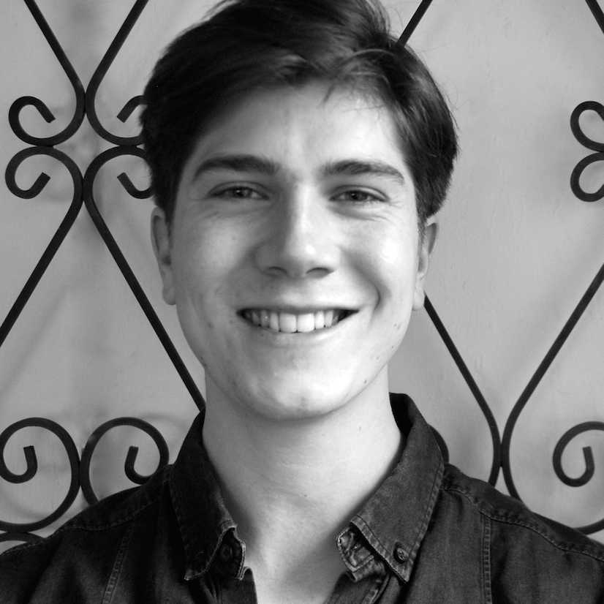
(Bern, Switzerland)
Maximilian Grossenbacher was born in Bern (CH) in 1991, but grew up in Collabassa, a little village in the Italian region of Liguria from 1996 to 2002. Maximilian began seriously pursuing piano and double bass in 1997 by taking piano lessons with his father and double bass lessons with Thierry Vera of the Monaco Symphony Orchestra until 2002. In this period he received the first price at the ''Concour International de Piano'', the third price at the ''Concour National de la Contrabasse'' in Paris and a special Recognition Award for Outstanding achievements obtained by Princess Antoinette Grimaldi (Monaco). In 2002 Maximilian moved back to Bern, Switzerland. When 15, he started his studies in Jazz at the Bern University of the Arts where he earned his Bachelor of Music in Double Bass in July 2010 under the tutelage of Thomas Dürst and Jonas Tauber. Upon graduation, Maximilian completed one year of military services. Subsequently, he resumed his post-graduate studies in composition where he studied with Dieter Ammann, Django Bates and Frank Sikora. Currently, he plays in different ensembles and bands such as Jazzator, Con’Fusion Trio, Vertigo Ensemble, Ensemble Hodiernis, in many others as a sideman, and works as a composer on different projects.

Marina Sobyanina
(Bern, Switzerland)
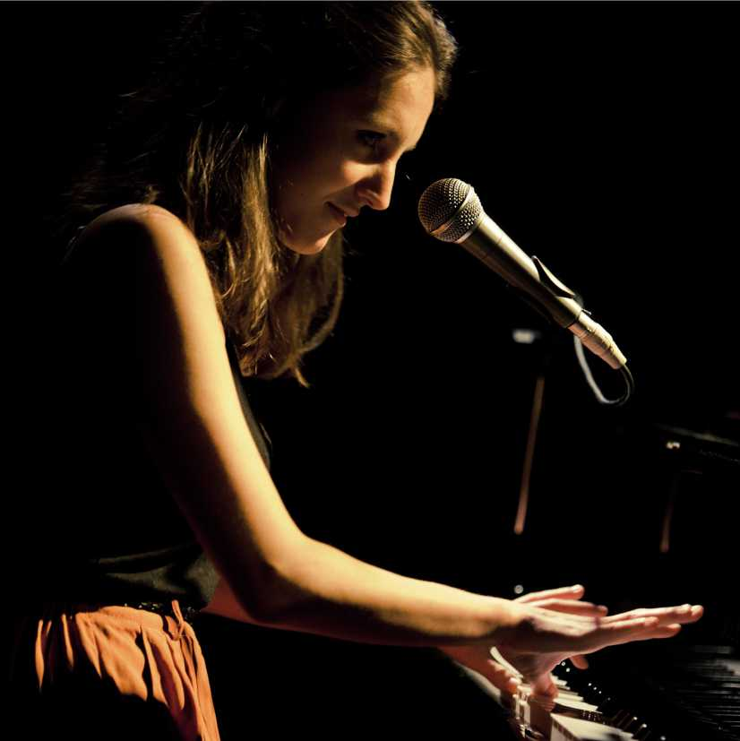
Marina Sobyanina (b. 1986) is a composer, a pianist and a singer. She was born in Sarov into a family of nuclear physicists. At present she is taking a course of composition in Bern, Switzerland, with professors Dieter Ammann, Xavier Dayer, Martin Streule, Django Bates and others. She graduated from the vocal department of Moscow College of Arts in 2005, Russian State University for Humanities (major –Art Criticism) in 2010 and Gotland School of Music Composition (Visby, Sweden) in 2011. In 2009 she founded the JAZZATOR group that has gradually become an international quintet going on tours around Europe and playing music created on the borderlines of avant-gard, jazz and free improvisation. She has composed music for a number of theatrical performances (the Moscow Art Theatre after A.P. Chekhov, The Meyerhold Theatre Centre, the Psilicone theatre (Lithuania), the Yekaterinburg Musical Comedy Theatre etc.) and films (“Repetitsii” (“Rehearsals”), the International Moscow Film Festival 2013). She has created numerous pieces for various ensembles and orchestras, including the Sirius String Quartet (USA), the Ballbreaker Ensemble (Switzerland) and the Klapparat Saxophone Orchestra (Switzerland).

