Marcin Jachim
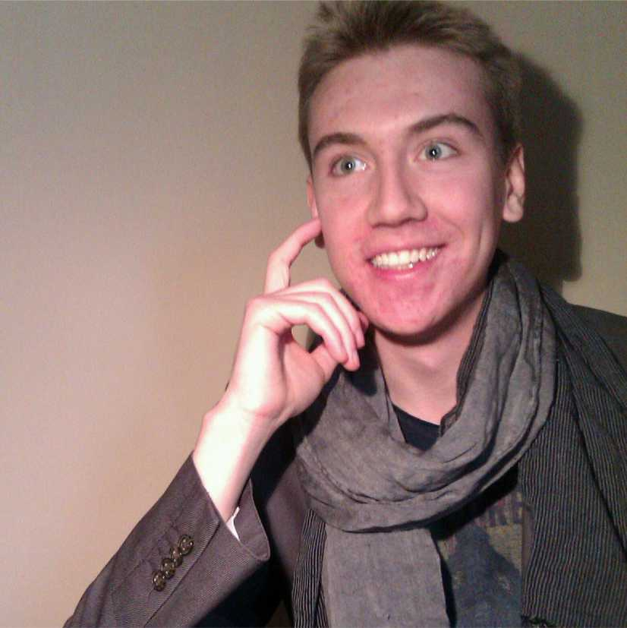
(Warsaw, Poland)
Marcin Jachim (*1993) - Polish composer, pianist and trumpeter. After twelve years music education, he started studying cultural studies at Cardinal Stefan Wyszyński University in Warsaw. Since October, 2013 he is studying composition at Fryderyk Chopin University of Music in Warsaw. In May, 2014 his piece for two multi-percussions "Kadesh", got the 3rd prize (the first prize was not awarded) in The Competition for Young Composers organized by Gorzow Philharmony.

Alexander Khubeev
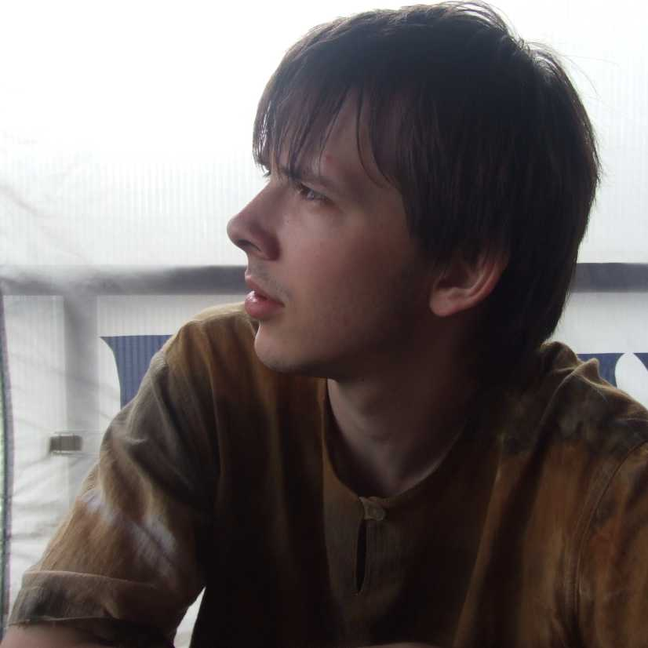
(Perm, Russia)
Alexander Khubeev was born on December 28, 1986 in Perm. In 2011 he graduated from the Composition Department of Moscow State Conservatory after P.I. Tchaikovsky and in 2014 he finished his post-graduate course at the same institution (Yuri Kasparov’s composition class, Igor Kefalidi’s electro-acoustic music class).
He participated in the workshops given by the composers Beat Furrer, Ivan Fedele, Mark Andre, Philipp Leroux, Chaya Czernowin, Martijn Padding, to name a few. He is a participant of the First International Young Composers Academy in Tchaikovsky city, 2011 (guest professors - Franck Bedrossian and Pierluigi Billone), the composers’ school in Nizhny Novgorod, 2013 (guest professors - Johannes Kreidler and Sergey Nevsky).
He was awarded a grant to attend International Summer Courses for New Music in Darmstadt (Germany, 2014) and won various prizes and diplomas at all-Russia and international contests held in Russia, Ukraine, Italy, Argentina and the USA. He was among the finalists of Gaudeamus Music Prize (Netherlands, 2013).
His music has been performed in various cities of Argentina, Armenia, Germany, the Netherlands, Spain, Italy, Cyprus, Russia, the USA, Ukraine, and France. It was on the programme of various festivals, such as “La Biennale di Venezia” (Venice, Italy), “MATA” (New York, USA), “Forum Neue Kammermusik” (Hannover, Germany), “Gaudeamus MusicWeek” (Utrecht, Netherlands), “Darmstadt ferienkurse” (Darmstadt, Germany), “Moscow Forum” (Moscow, Russia), “The Dyagilev Festival” (Perm, Russia), “Drugoe prostranstvo” (“Different space”) (Moscow, Russia), “Moscow Autumn” (Moscow, Russia), “Pifijskie igry-2007” (“Pythian Games”) (St Petersburg, Russia), "Opus 52" (Nizhny Novgorod, Russia).
Among the performers of his music we should name the Perm Opera House Symphony Orchestra, the Symphony Orchestra of the Ministry of Defence of Russia, the Dubna Symphony Orchestra, the “Soloists of Nizhny Novgorod” chamber orchestra, IEMA (Germany), ExNovo (Italy), ALEPH (France), Vertixe Sonora (Spain), Uusinta (Finland), Vortex (Switzerland), Illinois Modern (USA), DAMUS (Argentina), the Moscow Ensemble of Contemporary Music, the Studio for New Music, Mark Pekarsky’s Percussion Ensemble, Gam-Ensemble, eNsemble, the Cantando string quartet and many others.
His music has been broadcast by Radio Russia, Radio Orfey, France Musique (France), ARTxFM (USA) to name a few.
Alexander Khubeev is a member of the Union of Composers of Russian Federation. In 2011 he was the composer in residence of GAM- Ensemble.

Mikko Nisula
(Helsinki, Finland)
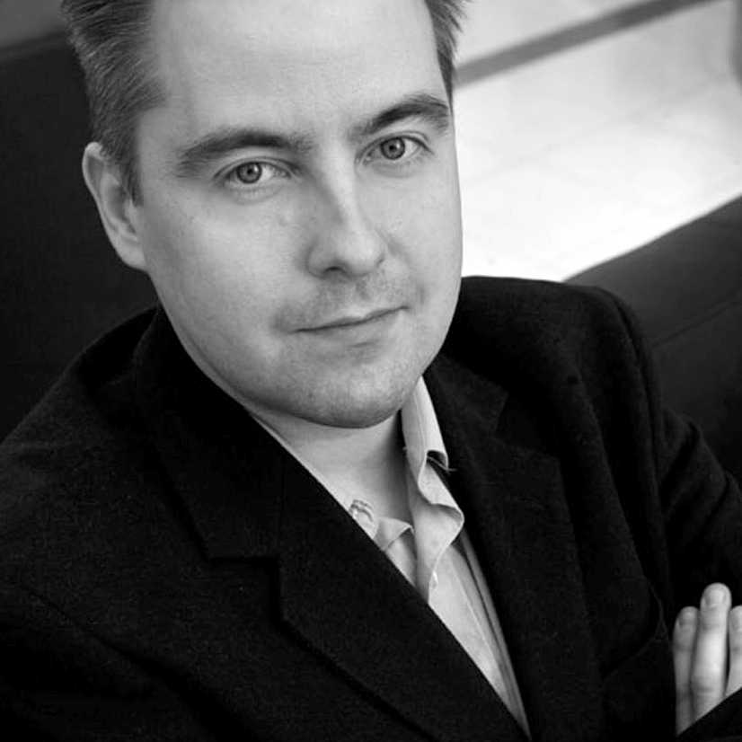
Mikko Nisula (b. 1974) studied musicology at the University of Helsinki and composition at the Rimsky-Korsakov Conservatory in Saint-Petersburg with Professor Boris Tischenko. Later he completed his studies in a master-class with the Belgian composer Philippe Boesmans. Since 2007, Nisula has been working on the critical edition of Fredrik Pacius’s (1809-1891) Complete Works of Musical Drama. As a composer, Nisula can be characterized as a neoromantic, who has also absorbed into his music various other stylistic influences, according to the mood and subject of the each composition. Among his central works are Sinfonia concertante (2007-2009), the orchestral song cycle Salaperäisiä unia (Mysterious Dreams, 2005), three chamber concertos (2001-2008), as well as the compositions on Persian subjects Mithras (2011) and Ishtar (2012).

Alexander Zhemchuzhnikov
(Yekaterinburg, Russia)
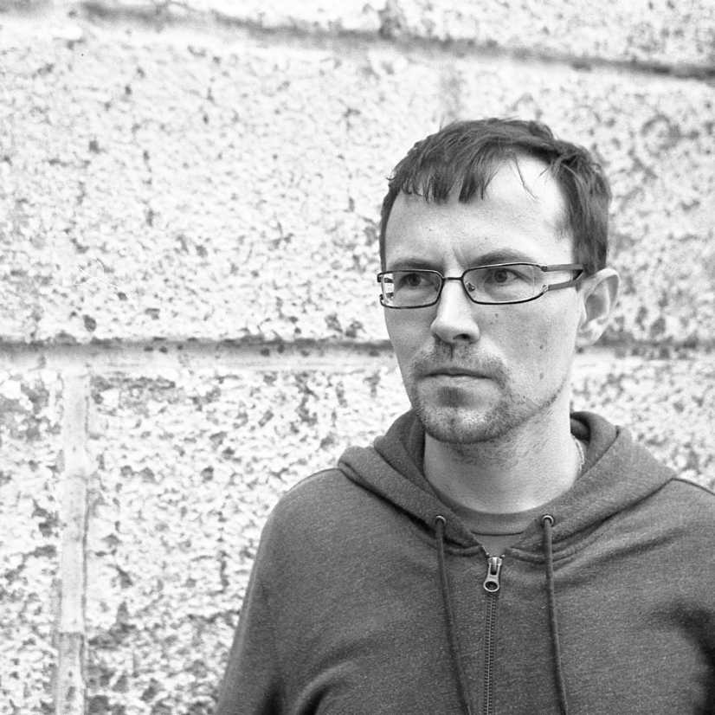
Alexander Zhemchuzhnikov was born in Bereznyaki, Perm Region, Russia. In Bereznyaki Musical College he was introduced to the charming nature of the Russian national instrument balalaika. He hadn’t attended a Music School – his only source of basic musical education was his records of modern groups, such as Napalm Death, Carcass and Slayer. Then, by God’s will and by the consent of A.N. Nimensky, the Head of the Composition Department, Alexander entered the Urals State Conservatory after M.P. Mussorgsky. He was studying the intricacies of composition under the kind supervision of Vladimir Kobekin for seven years (though his postgraduate course remained unfinished). At present he is the founding father of the most experimental orchestra in Russia – “Drugoj Orchestr” (“A Different Orchestra”). He is also creating various projects in the Ural Cultural Centre, the Yekaterinburg History Museum and in other concert venues of the city.

Elmir Nizamov
(Kazan, Russia)
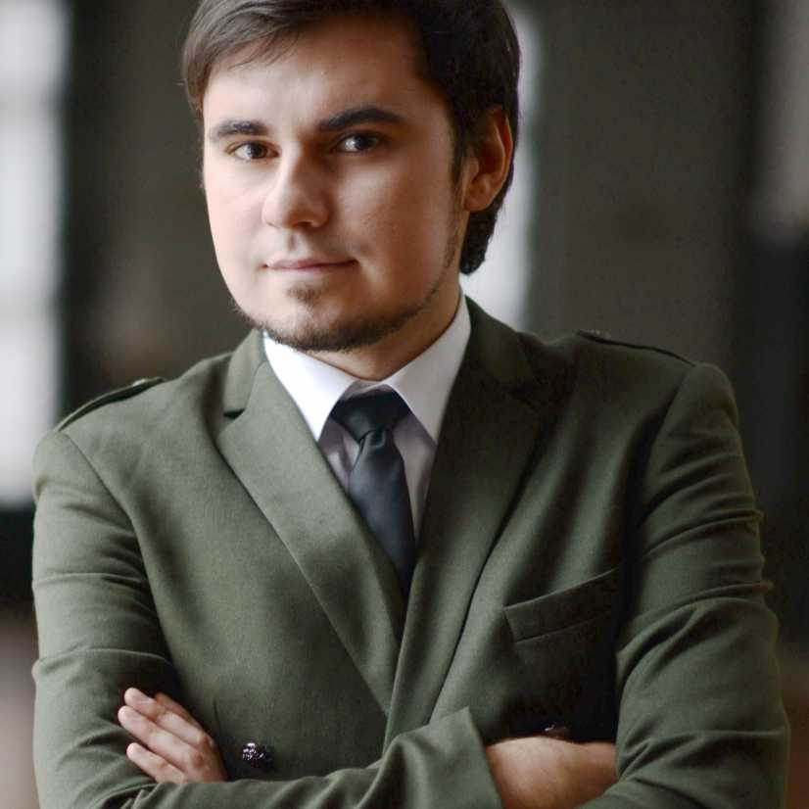
Elmir Nizamov was born on December 24, 1986, in Ulyanovsk.
In 2011 he graduated from the Composition Department of Kazan State Conservatory after N. Zhiganov (prof. A. Luppov’s class). At present he is taking a postgraduate course and holding a teaching position at the same institution.
Elmir Nizamov is a member of the Union of Composers of the Russian Federation; he is also the Head of Tatarstan Branch of the Youth Department of the Union (MolOt) and a member of its Expert Board.
Elmir has attended several seminars supervised by the president of the Contemporary Music Association V. Yekimovsky. In 2012 he stayed as a trainee at The Arnold Schönberg Center (Vienna). He has participated in a number of contemporary music festivals in various cities of Russia, Austria, Germany, Canada, Armenia, Ukraine and Belorussia. He is the First Prize-winner of the Kabalevsky Contest of Young Musicians (Samara, 2008), the winner of the First International Composers’ Competition “Connecting Music” (Kiev, 2009), a laureate of the contest for creating the compulsory piece for the III All-Russia Open Contest of Brass Ensembles (Kazan, 2010), a finalist of the international composers’ contest “Shag vlevo” (“A Step to the Left”) (St Petersburg, 2011), a laureate of the international contest “The Composer of the XXI c.” (Moscow, 2013), the winner of the all-Russia composers’ contest held by Orfey Radio (Moscow, 2013), and a recipient of a Certificate of Recognition for his participation in the Andrey Petrov International Composers’ Competition (st Petersburg, 2014).

Anton Svetlichny
(Rostov-on-Don, Russia)
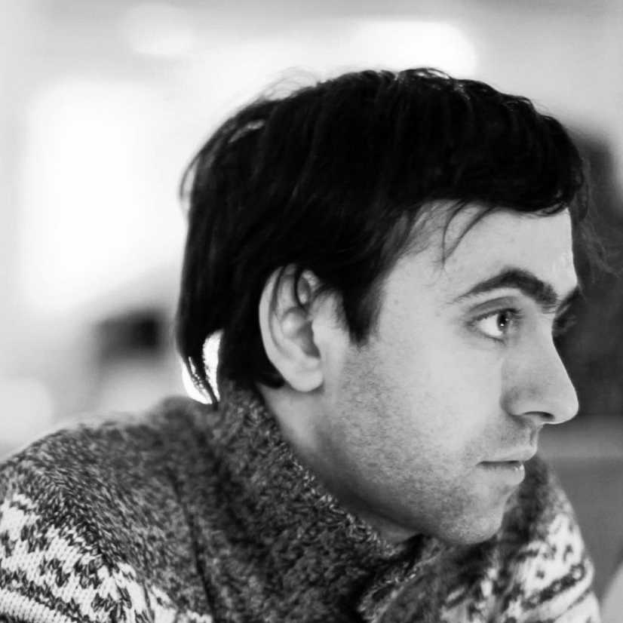
Anton Svetlichny (b. 1982) is a Russian composer. He graduated from Rostov Conservatory in 2004 (prof. V. Khodosh’s class). He took part in the All-Russia Seminar of Young Composers supervised by V. Yekimovsky (Moscow, 2004-2006). He also participated in the workshops given by L. Andriessen, M. Padding, R. de Man (Netherlands), P. Hurel (France), B. Furrer, L. Dowling (Austria), V. Tarnopolsky (Russia). Anton attended the classes taught by Pierluigi Billone (Italy) Franck Bedrossian (France) during the First International Young Composers Academy in Tchaikovsky city (2011).
Anton Svetlichny’s music has been performed in Russia (Moscow, St Petersburg, Nizhny Novgorod, Yekaterinburg, Perm, Ufa, Voronezh, Rostov-on-Don), Ukraine, Latvia, Germany, France, Switzerland, the Netherlands, Spain, Turkey, Hong Kong. The performers included the Moscow Ensemble of Contemporary Music, the Studio for New Music, GAM-Ensemble (Moscow), eNsemble, MolOt - Ensemble (St Petersburg), Nostri Temporis (Ukraine), Hong Kong Camerata (Hong Kong), ums'n'jip (Switzerland), Natalya Pshenichnikova (voice), Sergey Chirkov (accordion), Alexey Shmurak (piano), various Russian orchestras and chamber ensembles.
Anton has participated in various festivals and projects, including ISCM World Music Days (Hong Kong, 2007), International Summer Courses for New Music in Darmstadt (Germany, 2010), The Avignon Festival (France, 2012), Gaudeamus Muziekweek (Netherlands, 2013), Forum Wallis (Switzerland, 2014), SIRGA Festival (Spain, 2014), “Exposition” (Moscow, 2008), “Drugoe prostranstvo” (“Different space”) (Moscow, 2009), “Hamlet-machine” (Moscow, Moscow Art theatre, 2009), “Livetrack” (Moscow, Moscow Centre for Contemporary Art, 2010), «Tax‐Free» (St Petersburg, 2010), “Muzyka teney” (“Music of shadows”) (Moscow – Nizhny Novgorod, 2010), “Pin-club” (Yekaterinburg, 2010‐2011), “Exposition XXI” (Nizhny Novgorod, 2011, 2012), «russia.project» (St Petersburg – Rostov – Moscow - Switzerland, 2011‐2012), “From Avant-Garde to the Present Day” (St Petersburg, 2012, 2014), “Odna vos’maya” (“One-eighth”) (Rostov-on-Don, 2012, 2014).
Anton Svetlichny won the 1st Prize at the First Virtual Composers’ Contest held by the Tribune of Contemporary Music journal. He is also the winner (Grand prix and the Minor Prize for Ensamble) of the composers’ contest “Pifijskie igry-2007” (“Pythian Games-2007”) and a participant of “Pifijskie igry-2008” (St Petersburg, Russia).
Anton is a member of the “Structural resistance” composers’group.
He lives in Rostov-on-Don. Alongside his composer’s career he works as a teacher and as a musician (keyboard) in local rock-projects.
Henning Fuchs
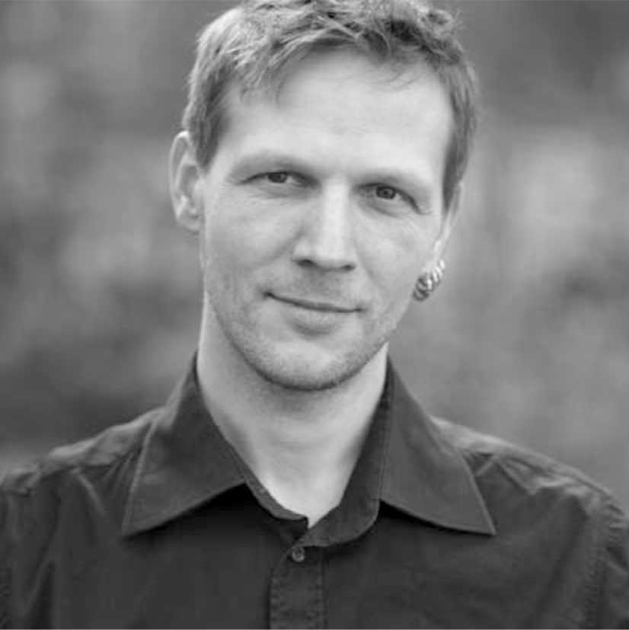
(Berlin, Germany)
The work of the composer Henning Fuchs includes film scoring, concert music, song writing and various album productions. His music embraces a wide range of styles and genres. Standing on the shoulders of giants, Henning studied at leading universities for music such as Sir Paul McCartney‘s Liverpool Institute for Performing Arts, the Royal College of Music London and the Academie for Film & Televison „Konrad Wolf“ Potsdam-Babelsberg. He received a scholarship for the 1st FilmSoundHamburg and participated at Masterclasses with well-known film composers such as Michael Giacchino, Patrick Doyle and Howard Shore. Henning has been nominated three years in a row for the Jerry Goldsmith Award and was awarded at the German-Russian Composer‘s Contest Music for Shadows in Nizhny Novgorod, Russia. Thanks to numerous cooperations with artists from various countries his work has gained internataional popularity. Currently Henning is working on a solo album. Furthermore he is closely collaborating with the renowned British composer Max Richter. Several international productions have yet benefited from his skills.

